- Node.js uses an event-driven, non-blocking model.
Node.js is a free, open-source JavaScript runtime that runs on Windows, Mac, Linux, and more.
execute JavaScript code outside of a web browser, enabling server-side development
Node.js excels at handling many simultaneous connections with minimal overhead, making it perfect for:
- Real-time applications (chats, gaming, collaboration tools)
- APIs and microservices
- Data streaming applications
- Command-line tools
- Server-side web applications

- asynchronous (non-blocking) programming.
Example :
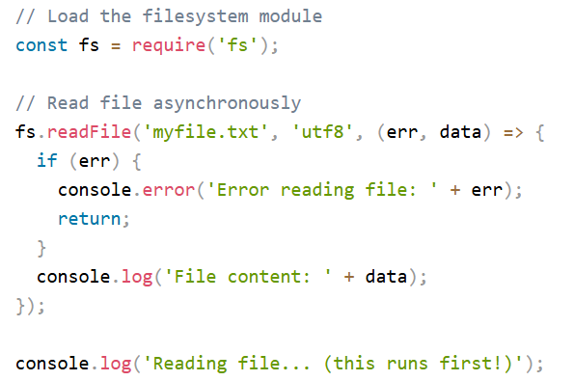
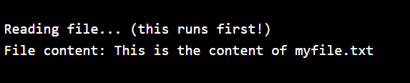

What Can Node.js Do?
- Web Servers: Create fast, scalable network applications
- File Operations: Read, write, and manage files on the server
- Database Interaction: Work with databases like MongoDB, MySQL, and more
- APIs: Build RESTful services and GraphQL APIs
- Real-time: Handle WebSockets for live applications
- CLI Tools: Create command-line applications
Initiate the Node.js File
- node myfirst.js and hit enter:
- Now, your computer works as a server!
- tries to access your computer on port 8080,
- browser, and type in the address: http://localhost:8080

Node.js JavaScript Requirements

Variables and Functions

Objects and Arrays

Asynchronous JavaScript

Key JavaScript Concepts
- Variables: let (mutable), const (immutable), var (legacy)
- Functions: Regular, arrow functions, and methods
- Objects & Arrays: Data structures for organizing data
- Modules: require() (CommonJS) and import/export (ES6)
- Error Handling: try/catch blocks

Node.js vs Browser
- both run JavaScript, but they have different environments and capabilities.
- Node.js is designed for server-side development
- while browsers are for client-side applications.
- APIs: Node.js provides APIs for file system, networking, and OS, which browsers do not.
Browsers provide DOM, fetch, and UI APIs not available in Node.js.
- Global Objects: Node.js uses global; browsers use window or self.
- Modules: Node.js uses CommonJS (require) and ES modules (import); browsers use ES modules or plain <script> tags.
- Security: Browsers run in a sandbox with limited access; Node.js has full access to the file system and network.
- Event Loop: Both environments use an event loop, but Node.js has additional APIs for timers, process, etc.
- Environment Variables: Node.js can access environment variables (process.env); browsers cannot.
- Package Management: Node.js uses npm/yarn; browsers use CDNs or bundlers.
What is Node.js Architecture?
single-threaded, event-driven architecture, handle many connections at once , efficiently and without blocking the main thread.
Non-blocking I/O, event-driven, single-threaded with event loop, asynchronous execution
Client Request Phase
Event Loop Phase
Request Processing

Response Phase

When to Use Node.js
- I/O-bound applications - File operations, database queries, network requests
- Real-time applications - Chat apps, live notifications, collaboration tools
- APIs - RESTful services, GraphQL APIs
- Microservices - Small, independent services

What is the Event Loop?

makes Node.js non-blocking and efficient.

asynchronous operations by delegating tasks and manage thousands of concurrent connections with a single thread.

Node.js follows these steps to handle operations:
- Execute the main script (synchronous code)
- Process any microtasks (Promises, process.nextTick)
- Execute timers (setTimeout, setInterval)
- Run I/O callbacks (file system, network operations)
- Process setImmediate callbacks
- Handle close events (like socket.on('close'))

- What is Asynchronous Programming?

lets Node.js handle many requests at once, without waiting for slow operations like file or database access.

Synchronous
- Blocks execution until complete
- Simple to understand
- Can cause delays
- Uses functions like readFileSync

Asynchronous
- Non-blocking execution
- Better performance
- More complex to handle

2.Introduction to Promises
- Pending: Initial state, operation not completed
- Fulfilled: Operation completed successfully
- Rejected: Operation failed

3. Introduction to Async/Await

Async/await makes asynchronous code look and more feel like synchronous code. It does not block the main thread, but is easy to follow and understand.

One of the advantages of async/await is that you can use traditional try/catch blocks for error handling, makin

g your code more readable.
4. Why Handle Errors?

prevents applications from crashing unexpectedly

makes debugging easier with proper error context

helps maintain application stability in production

What is a Module in Node.js?

building blocks of Node.js applications,
- Organizing code into manageable files
- Encapsulating functionality
- Preventing global namespace pollution
- Improving code maintainability and reusability

Node.js Frameworks

Node.js frameworks provide structure, organization, and common utilities for building web applications, APIs, and more.

It can handle many connections at once without waiting for one to finish before starting another.
This makes it great for real-time apps and high-traffic websites.
Here are some examples of what you can build with Node.js:
- Web servers and websites
- REST APIs
- Real-time apps (like chat)
- Command-line tools
- Working with files and databases
- IoT and hardware control
Save your code in a file, for example app.js then tun with node app.js

Node.js Built-in Modules
Node.js comes with many built-in modules to help you work with files, servers, paths, the operating system, and more.

